ACH Debit Test Case Document

Stripe supports accepting ACH payments - direct from bank accounts - alongside credit cards. ACH is currently supported only for Stripe businesses based in the U.S.

So, in Business Manager -> Merchant Tools -> Custom Preferences -> Stripe Configs -> Country Code (Stripe Payment Request Button) should be ‘US’ in order to be able to use ACH Debit.

Here is how to test it once Stripe is setup based on the SFRA or SiteGenesis Stripe Documentation.

**I. Place ACH Debit Order**

1. Open storefront and add one or more products to the basket

2. Navigate to Checkout

3. On Payment Step, select ‘ACH Debit’ as payment option

4. For Success, fill ‘ACH Debit’ form with:

Account Holder Name = some name

Account Type = Company or Individual

Account Number = 000123456789

Routing Number = 110000000

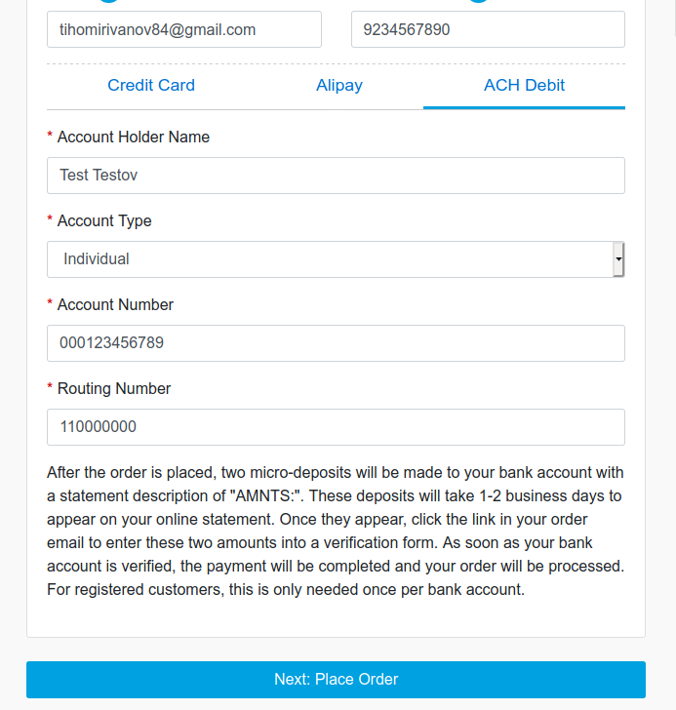

For other test scenarios (i.e. account closed), please refer to [https://stripe.com/docs/ach#testing-ach](https://stripe.com/docs/ach" \l "testing-ach)

5. Place Order

6. Open Order in Business Manager -> ‘Attributes’ Tab and verify:

‘Stripe payment intent in review’ is Checked

‘Stripe Bank Account Token’ and ‘Stripe Customer ID’ have values

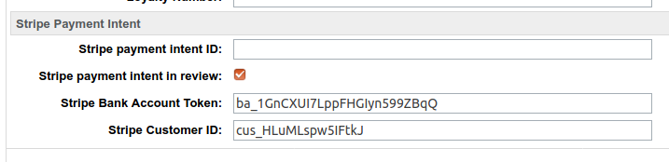

**II. Complete ACH Debit Order (Bank Verify and ACH Debit Charge)**

There is a test complete ACH Debit Order form (for both SFRA and SiteGenesis implementations):

https://your-sandbox-url.com/AchDebit-CompleteOrder

i.e.

https://dev01-us-brandname.demandware.net/on/demandware.store/Sites-RefArch-Site/en_US/AchDebit-CompleteOrder

For SiteGenesis open:

https://dev01-us-brandname.demandware.net/on/demandware.store/Sites-SiteGenesis-Site/en_US/AchDebit-CompleteOrder

2. Fill:

Order Number = Valid Order Number (from step I.)

First Amount = 32

Second Amount = 45

Please Note: To mimic successful and failed bank account verification, use these meaningful amounts (32 and 45).

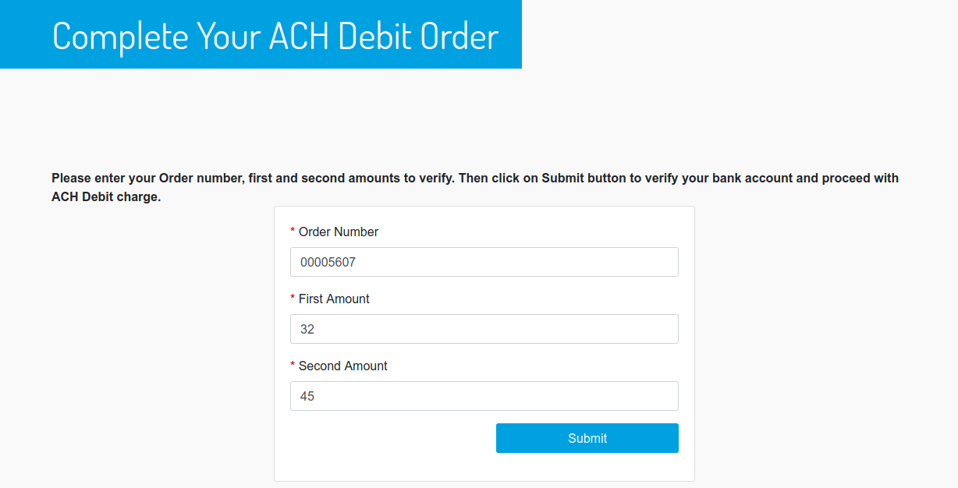

and Submit the form.

3. Verify Successful Message:

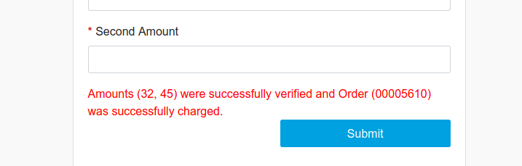

4. Open Order in Business Manager -> ‘Attributes’ Tab

‘Stripe payment intent in review’ is now Unchecked

